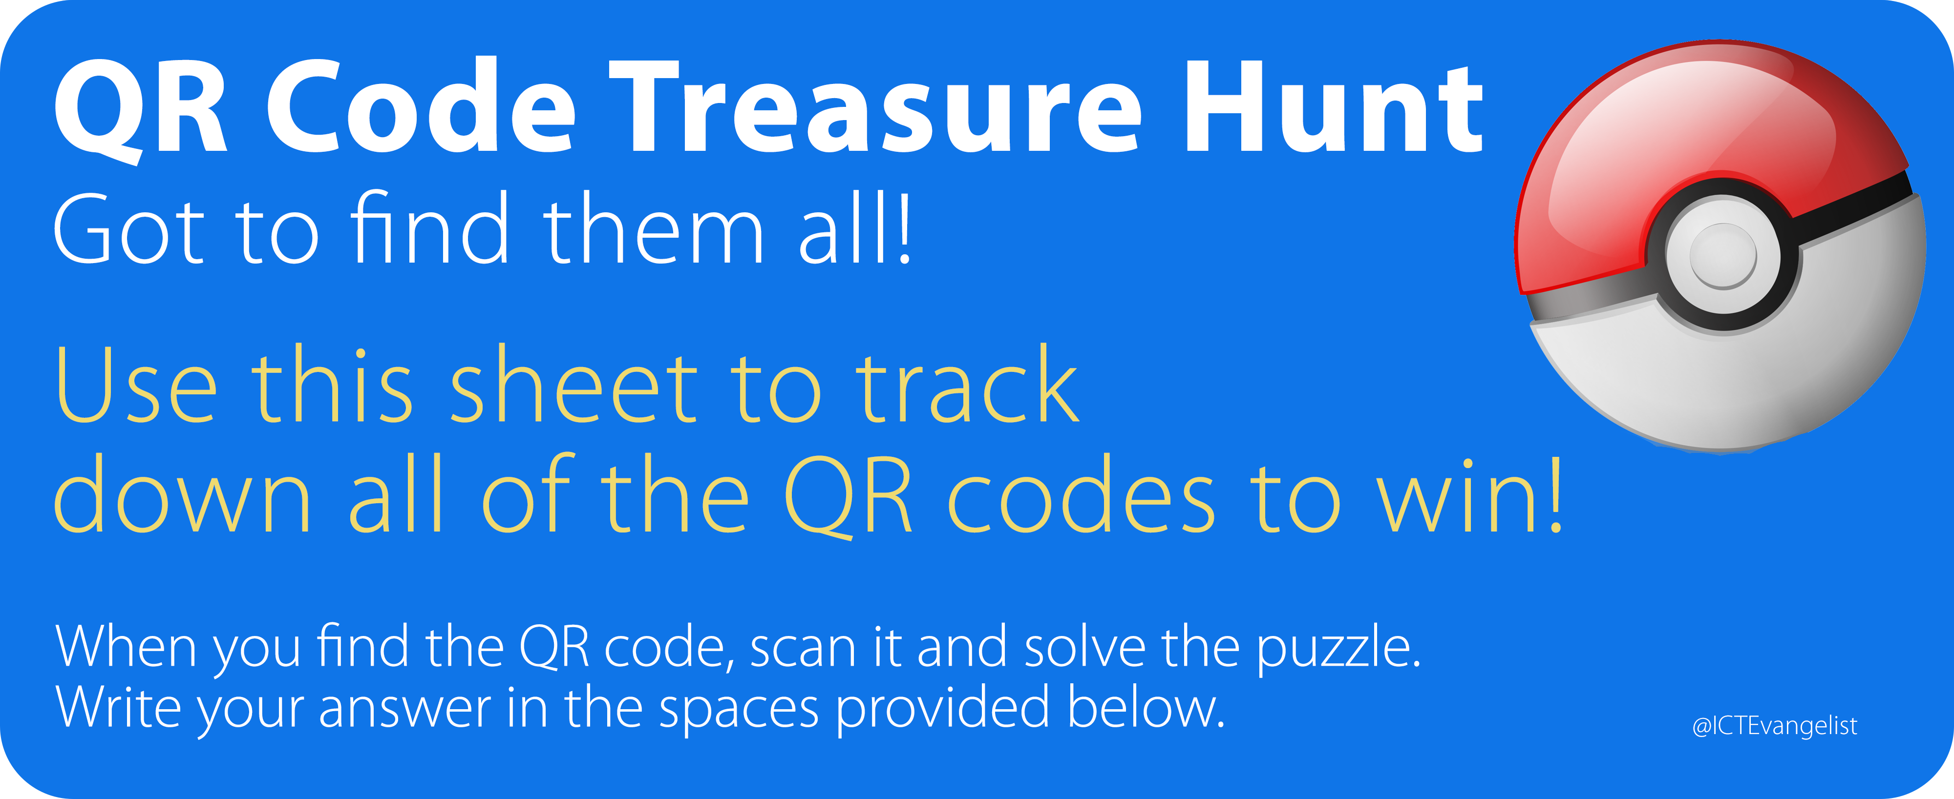
Number | Question location | Answer
1 | Insert location to find QR code here…
2
3
4
5
6
7
8
9
10
11
12
13
14
15
16
17
18
19
20



